HTTP

🔹 What is an HTTP Request?
HTTP (HyperText Transfer Protocol) is how your browser communicates with websites. When you visit a site, your browser sends an HTTP request to the server, and the server responds with an HTTP response (like a webpage).

What is HTTP?
The Hypertext Transfer Protocol (HTTP) is designed to enable communications between clients and servers.
HTTP works as a request-response protocol between a client and server.
Example: A client (browser) sends an HTTP request to the server; then the server returns a response to the client. The response contains status information about the request and may also contain the requested content.

HTTP Methods
- GET
- POST
- PUT
- HEAD
- DELETE
- PATCH
- OPTIONS
- CONNECT
- TRACE
The two most common HTTP methods are: GET and POST.

The GET Method
GET is used to request data from a specified resource.
Note that the query string (name/value pairs) is sent in the URL of a GET request:
/test/demo_form.php?name1=value1&name2=value2
Some notes on GET requests:
- GET requests can be cached
- GET requests remain in the browser history
- GET requests can be bookmarked
- GET requests should never be used when dealing with sensitive data
- GET requests have length restrictions
- GET requests are only used to request data (not modify)

The POST Method
POST is used to send data to a server to create/update a resource.
The data sent to the server with POST is stored in the request body of the HTTP request:
POST /test/demo_form.php HTTP/1.1
Host: w3schools.com
name1=value1&name2=value2
Some notes on POST requests:
- POST requests are never cached
- POST requests do not remain in the browser history
- POST requests cannot be bookmarked
- POST requests have no restrictions on data length

Compare GET vs. POST
The following table compares the two HTTP methods: GET and POST.
 | GET | POST
BACK button/Reload | Harmless | Data will be re-submitted (the browser should alert the user that the data are about to be re-submitted)
Bookmarked | Can be bookmarked | Cannot be bookmarked
Cached | Can be cached | Not cached
Encoding type | application/x-www-form-urlencoded | application/x-www-form-urlencoded or multipart/form-data. Use multipart encoding for binary data
History | Parameters remain in browser history | Parameters are not saved in browser history
Restrictions on data length | Yes, when sending data, the GET method adds the data to the URL; and the length of a URL is limited (maximum URL length is 2048 characters) | No restrictions
Restrictions on data type | Only ASCII characters allowed | No restrictions. Binary data is also allowed
Security | GET is less secure compared to POST because data sent is part of the URL  Never use GET when sending passwords or other sensitive information! | POST is a little safer than GET because the parameters are not stored in browser history or in web server logs
Visibility | Data is visible to everyone in the URL | Data is not displayed in the URL

The PUT Method
PUT is used to send data to a server to create/update a resource.
The difference between POST and PUT is that PUT requests are idempotent. That is, calling the same PUT request multiple times will always produce the same result. In contrast, calling a POST request repeatedly have side effects of creating the same resource multiple times.

The HEAD Method
HEAD is almost identical to GET, but without the response body.
In other words, if GET /users returns a list of users, then HEAD /users will make the same request but will not return the list of users.
A HEAD request is useful for checking what a GET request will return before actually making a GET request - a HEAD request can read the Content-Length header to check the size of the file, without actually downloading the file.

The DELETE Method
The DELETE method deletes the specified resource.

The PATCH Method
The PATCH method is used to apply partial modifications to a resource.

The OPTIONS Method
The OPTIONS method describes the communication options for the target resource.

The CONNECT Method
The CONNECT method is used to start a two-way communications (a tunnel) with the requested resource.

The TRACE Method
The TRACE method is used to perform a message loop-back test that tests the path for the target resource (useful for debugging purposes).

🔸 Basic Structure of an HTTP Request
Here’s a simple example of a GET request:
makefile

GET /login HTTP/1.1
Host: example.com
User-Agent: Mozilla/5.0
Cookie: sessionid=abc123

Breakdown:
- GET /login → You’re asking for the /login page.
- Host: → The domain you're sending the request to.
- User-Agent: → Info about the browser/client.
- Cookie: → Authentication/session data.

🔸 Common HTTP Methods
Method | What It Does | Example Use
GET | Retrieve data | View a webpage
POST | Send data | Submit a form
PUT | Update data | Edit user info
DELETE | Remove data | Delete account
OPTIONS | Ask what methods are allowed | Pre-flight request in CORS

🔸 Important Parts of HTTP for Bug Hunters
- Headers
  - Authorization: May contain tokens (JWTs, API keys).
  - Cookie: Session identifiers—can be tested for session fixation.
  - Content-Type: Tells the server what format you're sending (e.g., application/json, application/x-www-form-urlencoded).
  - User-Agent / Referer / Origin: Sometimes useful in bypassing filters or crafting CSRF attacks.
- Body (only in POST/PUT/DELETE)
Example POST request:
pgsql

POST /login HTTP/1.1
Host: example.com
Content-Type: application/x-www-form-urlencoded

username=admin&password=1234

🔸 Real-World Bug Hunting Use Cases
- SQL Injection: Tampering with GET/POST parameters.
sql

GET /search?query=1' OR '1'='1
- XSS (Cross-site Scripting): Injecting scripts via GET/POST.
javascript

POST /comment
comment=<script>alert(1)</script>
- CSRF (Cross-Site Request Forgery): Abusing authenticated requests via the victim's browser.
- Broken Authentication: Stealing cookies from Set-Cookie headers or JWT tokens from Authorization.
- Directory Traversal / File Inclusion:
bash

GET /download?file=../../etc/passwd

🔸 Tools for Inspecting HTTP Requests
- Burp Suite (must-have for bug bounty)
- Browser DevTools → Network tab
- Postman / cURL for testing requests manually
- OWASP ZAP

✅ Summary for Bug Hunting
- Understand the structure of requests.
- Learn how parameters are passed (query, body, headers).
- Practice tampering with values.
- Use Burp Suite to intercept and modify HTTP requests.
- Watch for authentication, input validation, and misconfigurations.

HTML Error Messages
When a browser requests a service from a web server, an error might occur, and the server might return an error code like "404 Not Found".
It is common to name these errors HTML error messages.
But these messages are something called HTTP status messages. In fact, the server always returns a message for every request. The most common message is 200 OK.
Below is a list of HTTP status messages that might be returned:

1xx: Information
Message: | Description:
100 Continue | The server has received the request headers, and the client should proceed to send the request body
101 Switching Protocols | The requester has asked the server to switch protocols
103 Early Hints | Used with the Link header to allow the browser to start preloading resources while the server prepares a response

2xx: Successful
Message: | Description:
200 OK | The request is OK (this is the standard response for successful HTTP requests)
201 Created | The request has been fulfilled, and a new resource is created
202 Accepted | The request has been accepted for processing, but the processing has not been completed
203 Non-Authoritative Information | The request has been successfully processed, but is returning information that may be from another source
204 No Content | The request has been successfully processed, but is not returning any content
205 Reset Content | The request has been successfully processed, but is not returning any content, and requires that the requester reset the document view
206 Partial Content | The server is delivering only part of the resource due to a range header sent by the client

3xx: Redirection
Message: | Description:
300 Multiple Choices | A link list. The user can select a link and go to that location. Maximum five addresses
301 Moved Permanently | The requested page has moved to a new URL
302 Found | The requested page has moved temporarily to a new URL
303 See Other | The requested page can be found under a different URL
304 Not Modified | Indicates the requested page has not been modified since last requested
307 Temporary Redirect | The requested page has moved temporarily to a new URL
308 Permanent Redirect | The requested page has moved permanently to a new URL

4xx: Client Error
Message: | Description:
400 Bad Request | The request cannot be fulfilled due to bad syntax
401 Unauthorized | The request was a legal request, but the server is refusing to respond to it. For use when authentication is possible but has failed or not yet been provided
402 Payment Required | Reserved for future use
403 Forbidden | The request was a legal request, but the server is refusing to respond to it
404 Not Found | The requested page could not be found but may be available again in the future
405 Method Not Allowed | A request was made of a page using a request method not supported by that page
406 Not Acceptable | The server can only generate a response that is not accepted by the client
407 Proxy Authentication Required | The client must first authenticate itself with the proxy
408 Request Timeout | The server timed out waiting for the request
409 Conflict | The request could not be completed because of a conflict in the request
410 Gone | The requested page is no longer available
411 Length Required | The "Content-Length" is not defined. The server will not accept the request without it
412 Precondition Failed | The precondition given in the request evaluated to false by the server
413 Request Too Large | The server will not accept the request, because the request entity is too large
414 Request-URI Too Long | The server will not accept the request, because the URI is too long. Occurs when you convert a POST request to a GET request with a long query information
415 Unsupported Media Type | The server will not accept the request, because the media type is not supported
416 Range Not Satisfiable | The client has asked for a portion of the file, but the server cannot supply that portion
417 Expectation Failed | The server cannot meet the requirements of the Expect request-header field

5xx: Server Error
Message: | Description:
500 Internal Server Error | A generic error message, given when no more specific message is suitable
501 Not Implemented | The server either does not recognize the request method, or it lacks the ability to fulfill the request
502 Bad Gateway | The server was acting as a gateway or proxy and received an invalid response from the upstream server
503 Service Unavailable | The server is currently unavailable (overloaded or down)
504 Gateway Timeout | The server was acting as a gateway or proxy and did not receive a timely response from the upstream server
505 HTTP Version Not Supported | The server does not support the HTTP protocol version used in the request
511 Network Authentication Required | 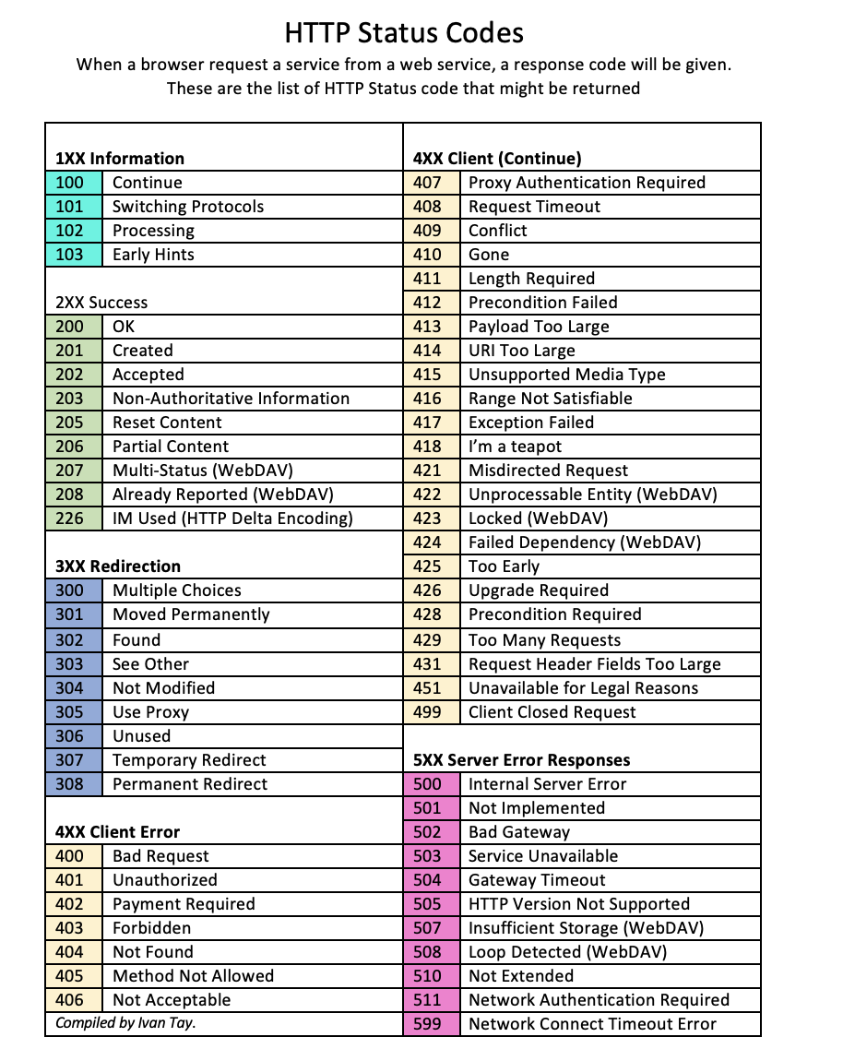  The client needs to authenticate to gain network access

